Module 10: Serverless basics

Sub-task 1 – create a "Weekly CSV Report" Lambda

Create a Lambda function:

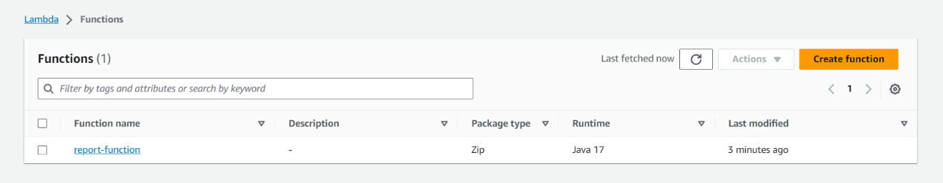

The AWS Lambda function should implement the following logic:

* Extract data from the DynamoDB table
* Generate report in CSV format with follow structure:
  + Trainer First Name.
  + Trainer Last Name.
  + Current month trainings duration summary time.

· Report should contain both active and inactive trainers.

· Report name should be as a template "Trainers_Trainings_summary_YYYY_MM".

· Inactive trainer with training duration summary equals to 0 should not be included into the report.

Below are some snippets of code for above statements

Uploaded the jar file of application in lambda function.

Change the runtime settings handler path with our applications handleRequest method

Trigger your Lambda manually. Ensure csv report is uploaded to S3 bucket.

The the csv file contain the details we uploaded

